**LAB# 04 Assignment**

**QUESTION# 01:**

**CODE:**

TITLE Q1 (Test.asm)

INCLUDE Irvine32.inc

.data

imm8 equ 5

val1 word 8

val2 word 15

val3 word 20

AEX word ?

.code

main PROC

mov ax, imm8

mov bx, val1

mov cx, val2

mov dx, val3

add ax, cx

sub ax, dx

add ax, bx

sub ax, imm8

mov AEX, ax

call DumpRegs

exit

main ENDP

END main

**OUTPUT SCREENSHOT:**

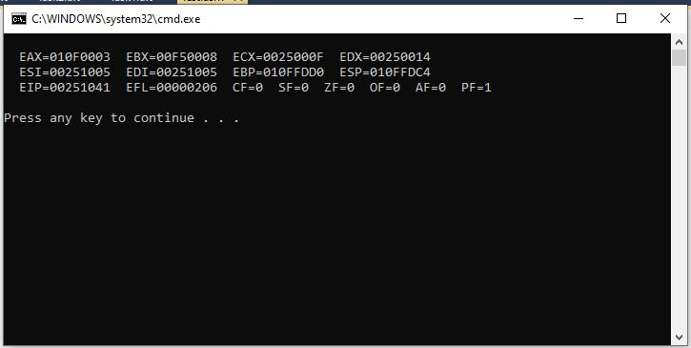

**QUESTION# 02:**

**CODE:**

TITLE Q2 (Test.asm)

INCLUDE Irvine32.inc

.data

hour word 24

.code

main PROC

SecondsInDay = 60*60

mov ax, SecondsInDay

mov dx, hour

mul dx

call DumpRegs

exit

main ENDP

END main

**OUTPUT SCREENSHOT:**

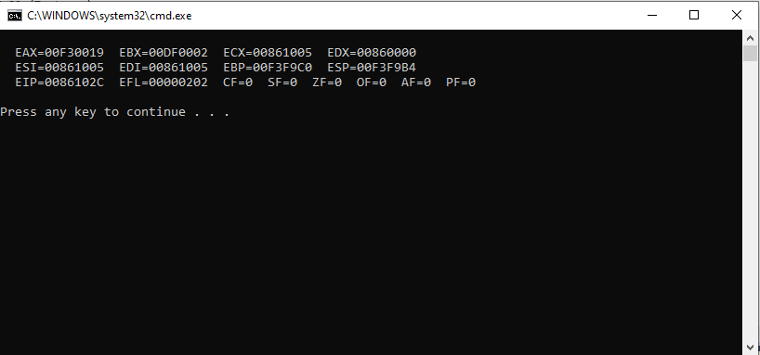

**QUESTION# 03:**

**CODE:**

TITLE Q3 (Test.asm)

INCLUDE Irvine32.inc

.data

side1 word 5

side2 word 10

area word ?

.code

main PROC

mov ax, side1

mov dx, side2

mul dx

mov bx, 2

div bx

call DumpRegs

exit

main ENDP

END main

**OUTPUT SCREENSHOT:**

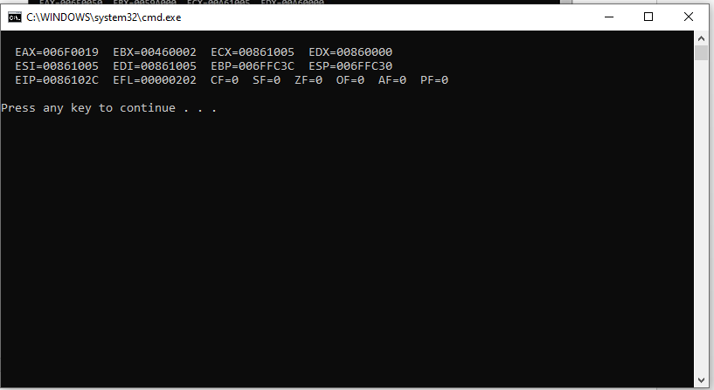

**QUESTION# 04:**

**CODE:**

TITLE Q4 (Test.asm)

INCLUDE Irvine32.inc

.data

operand1 byte 7h

operand2 byte 5h

final byte ?

.code

main PROC

mov al, operand1

mov dl, operand2

mul dl

mov final, dl

call DumpRegs

exit

main ENDP

END main

**OUTPUT SCREENSHOT:**

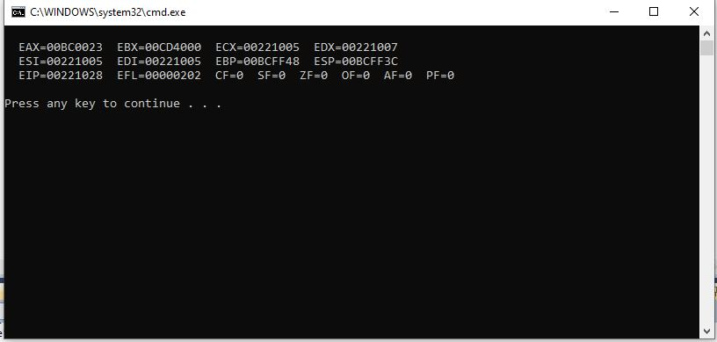

**QUESTION# 05:**

**CODE:**

TITLE Q5 (Test.asm)

INCLUDE Irvine32.inc

.data

x1 word 25

x2 byte 5

final byte ?

.code

main PROC

mov ax, x1

mov bl, x2

div bl

mov final, bl

call DumpRegs

exit

main ENDP

END main

**OUTPUT SCREENSHOT:**

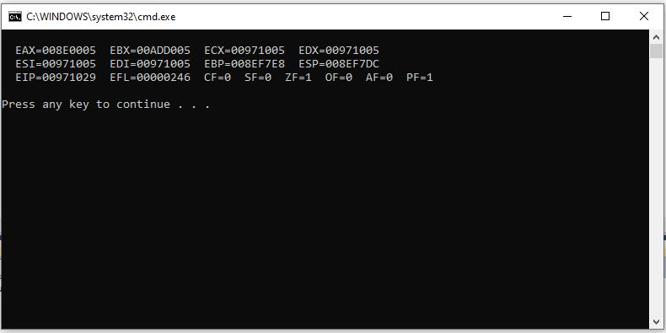

**QUESTION# 06:**

**CODE:**

.data

Val1 BYTE 10h

Val2 WORD 8000h

Val3 DWORD 0FFFFh

Val4 WORD 7FFFh

**i. Write an instruction that increments val2.**

**Ans:** inc val2

**ii. Write an instruction that subtracts val3 from EAX.**

**Ans:** sub eax, val3

**iii. Write instructions that subtract val4 from val2.**

**Ans:** mov ax, val2

sub ax, val4

**iv. If val2 is incremented by using the INC instruction, note down the values of flags.**

**Ans:** CF=0 SF=1 ZF=0 OF=0 AF=0 PF=0

**v. If val4 is incremented by using the INC instruction, note down the values of flags.**

**Ans:** CF=0 SF=1 ZF=0 OF=1 AF=1 PF=1

**vi. If val1 is decremented by using the DEC instruction, note down the values of flags.**

**Ans:** CF=0 SF=0 ZF=0 OF=0 AF=1 PF=1

**vii. If val3 is decremented by using the DEC instruction, note down the values of flags.**

**Ans:** CF=0 SF=0 ZF=0 OF=0 AF=0 PF=0